Chapter Three: The Hermetic Tree Of Life

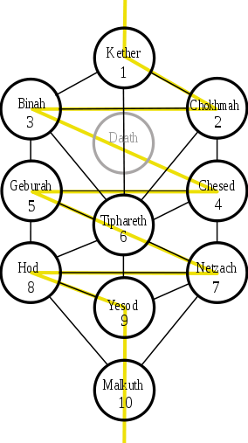
What Is The Hermetic Tree Of Life?
The Tree of Life is major part of a system known as Kabbalah. There are several branches of Kabbalah.[i ii iii] Here we will be analyzing the branch known as Hermetic Qabalah. This is an extremely complicated system that was developed over several centuries.[iv] Over that period the Hermetic Tree of Life has come to be associated with tarot cards, astrology, alchemy, numerology, old pagan gods, and numerous other systems.[v vi vii viii ix] These associations are used to flesh out the meaning of the various parts of the Hermetic Tree of Life.[x] The parts of the Tree of Life consist of several Sephiroth, which are drawn as circles in the diagram of the Tree of Life, and the several Paths that connect them. From top to bottom, left to right, the circles are named Kether, Chokmah, Binah, Daath, Chesed, Geburah, Tiphareth, Netzach, Hod, Yesod, and Malkuth.

Additional details on the Tree will be provided as we go along.

Difficulties Involved In Analyzing The Hermetic Tree Of Life
Difficulty in analyzing the Tree of Life arises due to the fact that none of the explanatory associations assigned to the parts of the Tree of Life are simple. For example, the Tarot cards are themselves a very complex system made of multiple components.[xi] As it is now, to analyze the Hermetic Tree of Life, one must also analyze at least several of these other complex systems.[xii]

The situation with the current system is hopeless. The solution presented here is to toss out all of the current system and start anew. This means original research must be carried out. Once this research is done one can re-introduce the old associations if desired, but as commentary on the system rather than as definitions.

Equating Love Numbers With The Sephiroth
At this point, we have thrown out the entire Tree and all of its supporting nomenclature. We continue the analysis by reintroducing as little as we can to build the Tree. Each step along the way will be accompanied by axioms stating exactly what is being done. To reconstruct the sephiroth, we need two axioms, shown below.

• Axiom 1: There are eleven sephiroth on the Tree of Life.
• Axiom 2: Each sephiroth is a unique thing, not a combination of other sephiroth.

With each sephiroth on the Tree of Life now defined as a thing in itself, we can assign each sephiroth to
a Love Number, as follows.

Kether = 1 | Binah = 4 | Geburah = 16 | Netzach = 64 | Yesod = 256 | Daath = 1024
Chokmah = 2 | Chesed = 8 | Tiphareth = 32 | Hod = 128 | Malkuth = 512

These numbers have no special significance other than they are a sequence of Love simple numbers. Also, the assignments are not correspondences. Rather the numbers are, for the purpose of this analysis,
identical to the sephiroth to which they are assigned. Put another way, we are not saying the number 1
has certain affinities with Kether, we are saying the Love number 1 and Kether are synonyms for the
purposes of the remainder of this analysis.

Daath is placed at the end due to it's controversial status as an actual sephiroth. In this analysis we will
consider it to be an actual sephiroth. Those who disagree can simply drop off Daath from the end of the
analysis.

We are now in a position to look at the paths on the Tree of Life.

The Paths On The Tree Of Life
There are several paths connecting the sephiroth on the Tree of Life. The sephiroth themselves are said to have objective realities that can be contacted through various forms of meditation and ritual. We do not concern ourselves here with the validity of this statement, rather we contrast it with the acknowledgment that the paths connecting the sephiroth are said to represent solely subjective realities.[xiii]

The first question we must ask is how many of these paths are there? The traditional answer is that there are 22 paths, one for each letter of the Hebrew alphabet and each trump card in the Tarot deck. What principle gives us 22 paths? There doesn't seem to be any such principle that is universally accepted. In the Book of Thoth, Aleister Crowley states:

Why should this be so? Why should these paths be arranged on the Tree in the way that the diagram shows? Why should there not be paths connecting the numbers 2 and 5 and the numbers 3 and 4? One cannot answer any of these questions.[xiv]

Dion Fortune states that there are .”secret paths”. on the Tree, pointing out paths that connect Daath with Yesod and with Chesed.[xv] Still other representations of the Tree of Life have 24 (non-secret) paths.[xvi]

Charles Stansford Jones gives several detailed reasons why he believes there should be no more than 22 paths,[xvii] but his reasoning is directly contradicted by Fortune's statements and versions of the Tree which have more than 22 paths.

The approach taken here is the number of paths placed on the Tree of Life is a convention, nothing more, and there are several conflicting conventions. Therefore, when we use Love to construct the paths, we'll do so in a manner that allows a path to connect any given sephiroth to any other. This gives us several new paths that have never been placed on the Tree of Life before. If there are traditions or individuals opposed to these new paths, they can append rules as to why such paths should not exist.

Defining The Paths On The Tree Of Life
We will define the paths as a mathematical function that transforms the energies of one sephiroth into
another. The following axiom does this.

• Axiom 3: Given any sephiroth on the Tree of Life, X, as a starting point, and any other sephiroth on the Tree, Y, as an ending point, there exists a function, f, of the form Y = f(X), which connects them.

This axiom gives us a total of 55 paths on the Tree of Life, rather than the traditional 22 paths.

Now the function f is just an interface, there is no body written with it. In other words we have no idea, at this point, what exactly the function f is doing to transform X into Y. Because nature of the paths is they are subjective and work differently for different people, I've decided to leave it like this. The body of f is undefined in this analysis, its contents are left up to case analysis by individuals to determine for themselves. One may reintroduce traditional correspondences to the paths, such as tarot trumps or Hebrew letters, as aids in determining exactly how each function works, if so desired.

Similarly, one may create new systems to cover the new paths. This is the subject of a future chapter.

Defining The Meanings Of The Sephiroth
The final step of this analysis is to define the meanings of the sephiroth, for all we know about them from Axiom 2 is that each one is different from the others, a thing in itself. We shall use axioms to make our definitions, but we shall be careful to stick to things known. We'll not be defining the sephiroth with the names of angels or knowledge obtainable only through special channels. Common sense will guide us.

Axiom 4: The following three forces exist: Power, sex, and consciousness.
Axiom 5: Each of these three forces can be divided into pairs of opposites.
Axiom 6: Each opposite can be further divided into passive and active modes.
Axiom 7: The pairs of opposites for power are 1) Ruling, and 2) Submissive.
Axiom 8: The pairs of opposites for sex are 1) Male, and 2) Female.
Axiom 9: The pairs are opposites for consciousness are 1) Feelings, and 2) Reason.
Axiom 10: Power is assigned to the sephiroth as follows: Kether = Active Submissive, Malkuth = Passive Submissive, Chesed = Passive Ruling, and Geburah = Active Ruling.
Axiom 11: Sex is assigned to the sephiroth as follows: Binah = Passive Female, Netzach = Active
Female, Chokmah = Active Male, Hod = Passive Male.
Axiom 12: Consciousness is assigned to the sephiroth as follows: Daath = Active Reason, Yesod = Passive Feelings, Tiphareth = Passive Reason and Active Feelings together.

With these 12 axioms we have a rebuilt, clearly defined Tree of Life. The Tree is much simpler, yet from this simplicity comes new information about the Tree that has never been presented before. This information takes the form of the majority of the 33 new paths connecting the sephiroth. Exploring this new information will be the topic of a future chapter.

The New Tree Of Life
The following pages presents images of what the new Tree of Life looks like, along with a few explanatory notes.

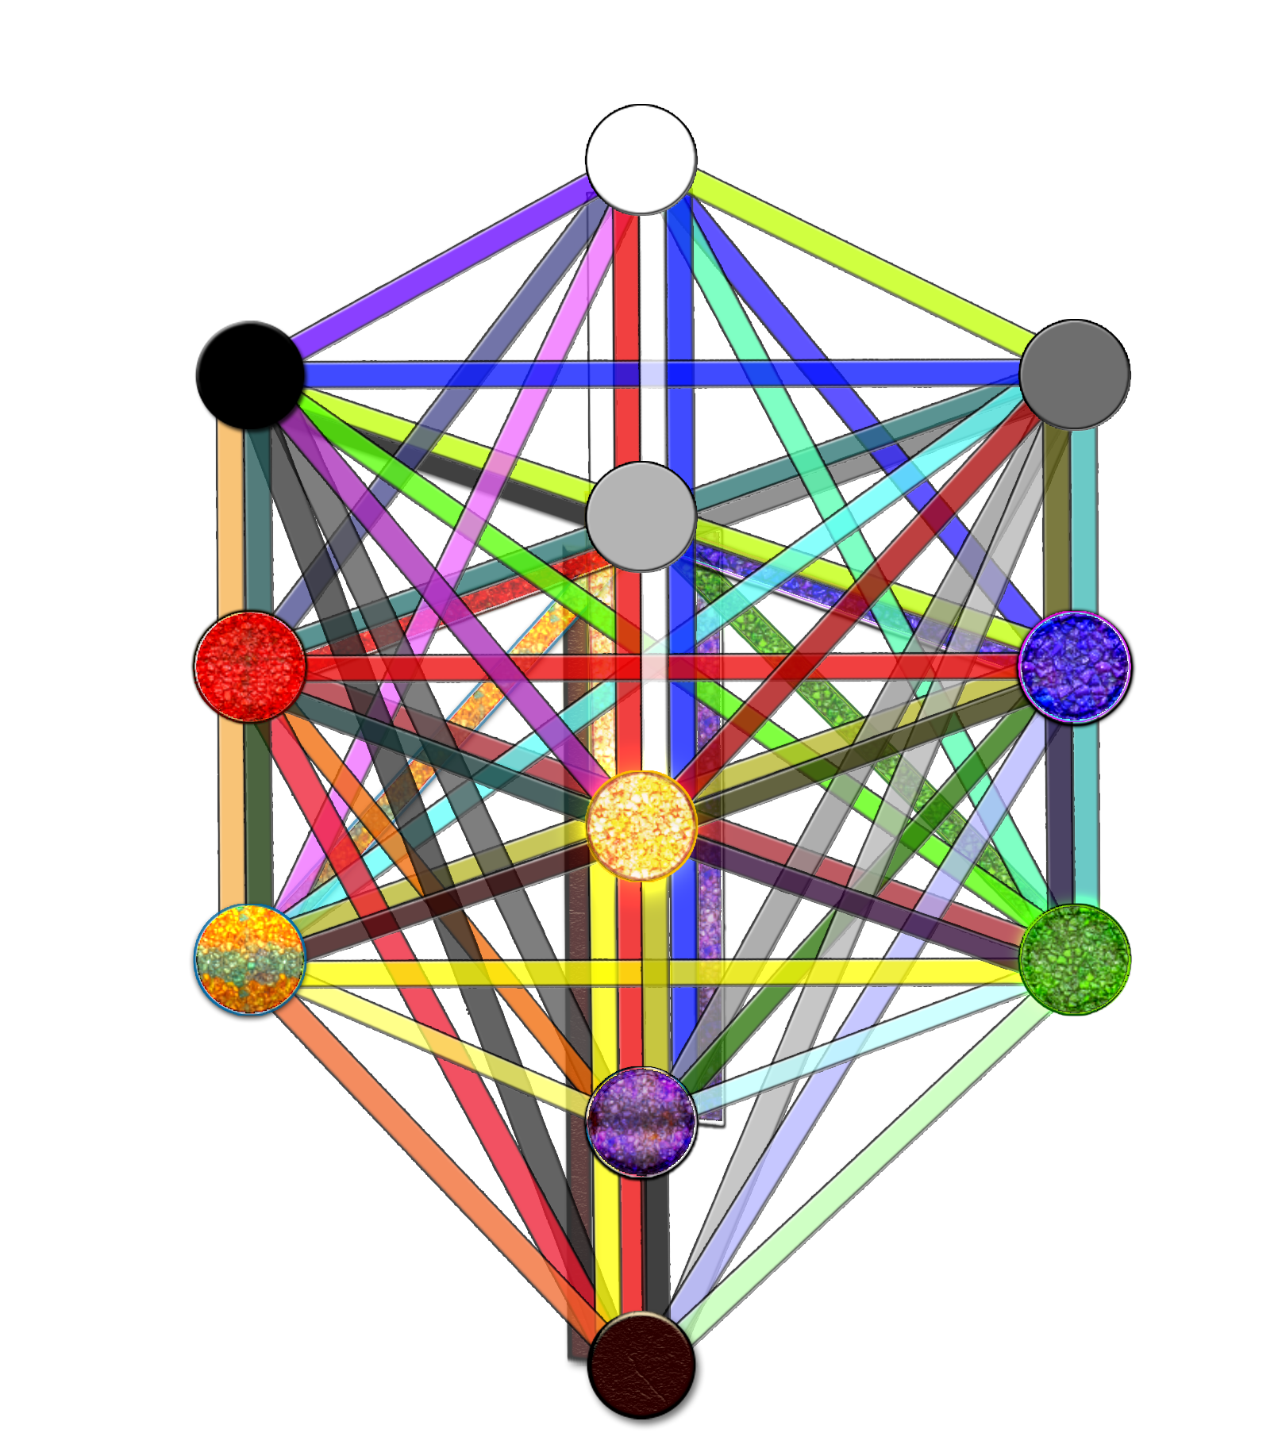
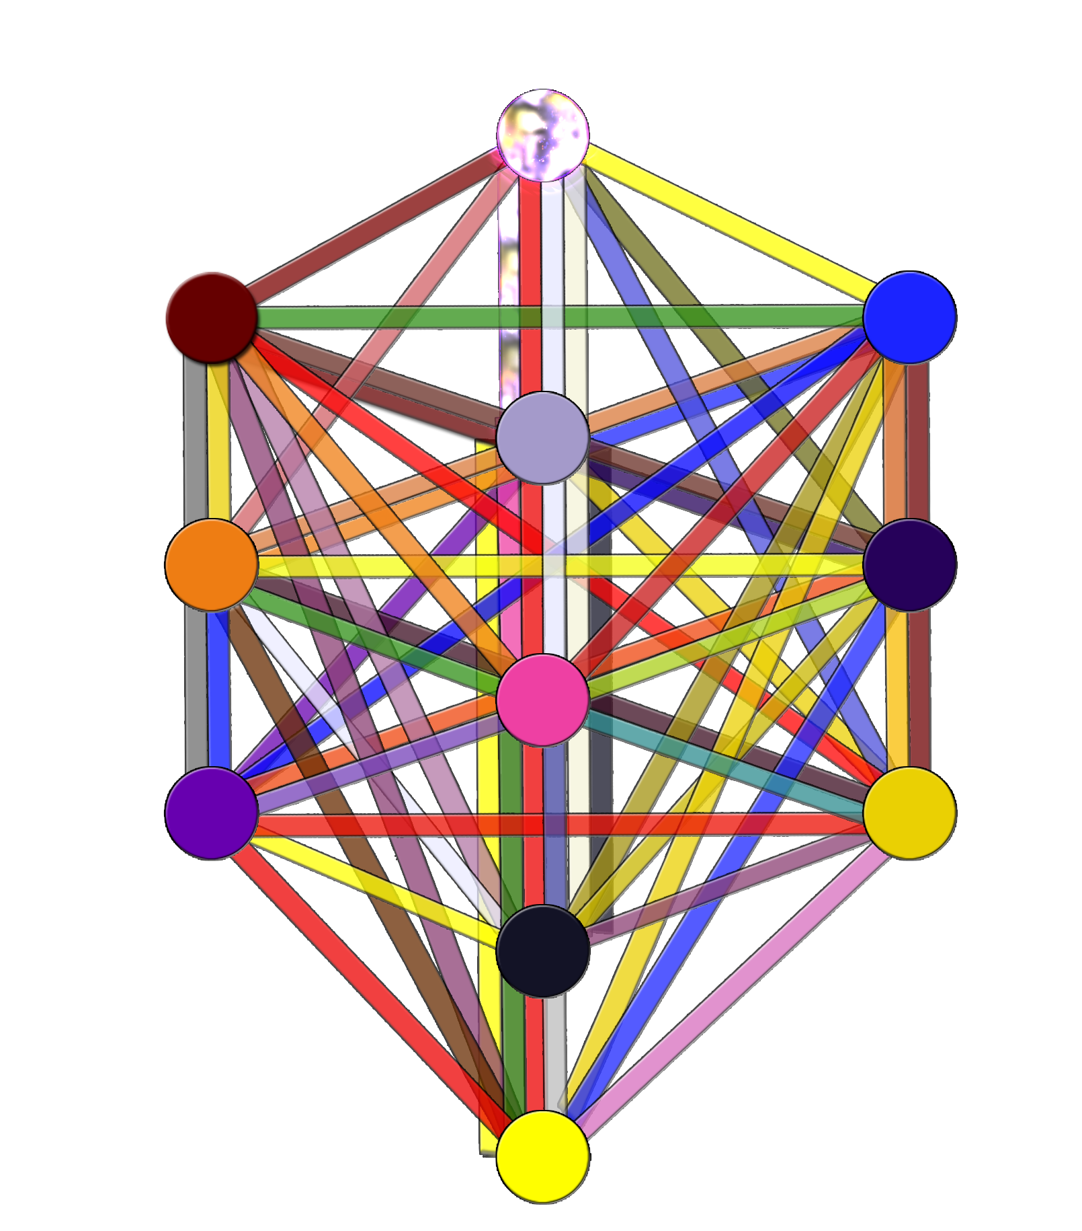
The new Tree of Life with all the paths is shown above. The paths are semi-transparent to symbolize that they are subjective.

On the left is what is traditionally known as the “King Scale” colors, which uses an additive color model (a system where the primary colors are red, green, and blue, all colors added together make white). Note that the path from Kether to Hod is not missing, it is colored “invisible”. On the right is the so-called “Queen Scale” colors, which uses a subtractive color model (a system where the primary colors are red, yellow, and blue, all colors added together make black).

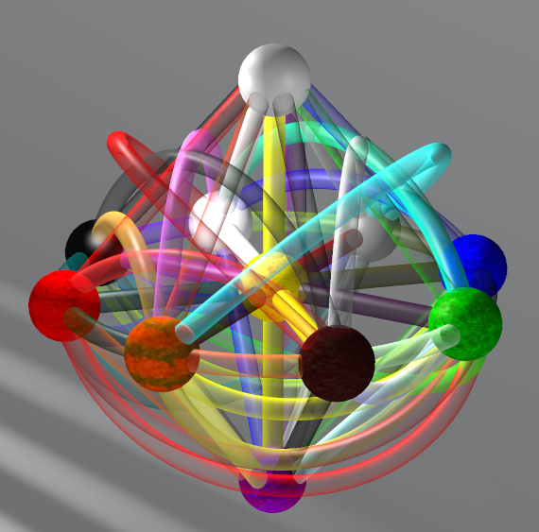
The Tree of Life drawn in 3D. Because we never defined axioms stating how the Tree was to be laid out, we can use different layouts as suit our needs.

In this image, the brown sphere in front is Malkuth. Going clockwise from Malkuth is Hod (orange), Geburah (red), Binah (black), Kether (white), Chokmah (gray), Chesed (blue), and Netzach (green). In the center is Tiphareth (yellow). The sphere at the top is Daath (light gray). The sphere at the bottom is Yesod (purple).
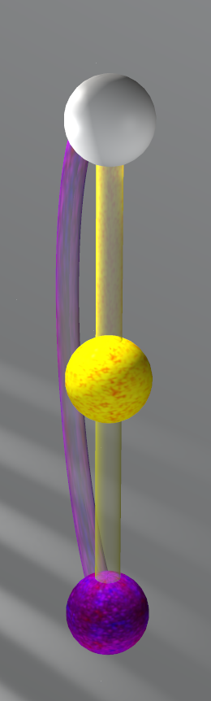
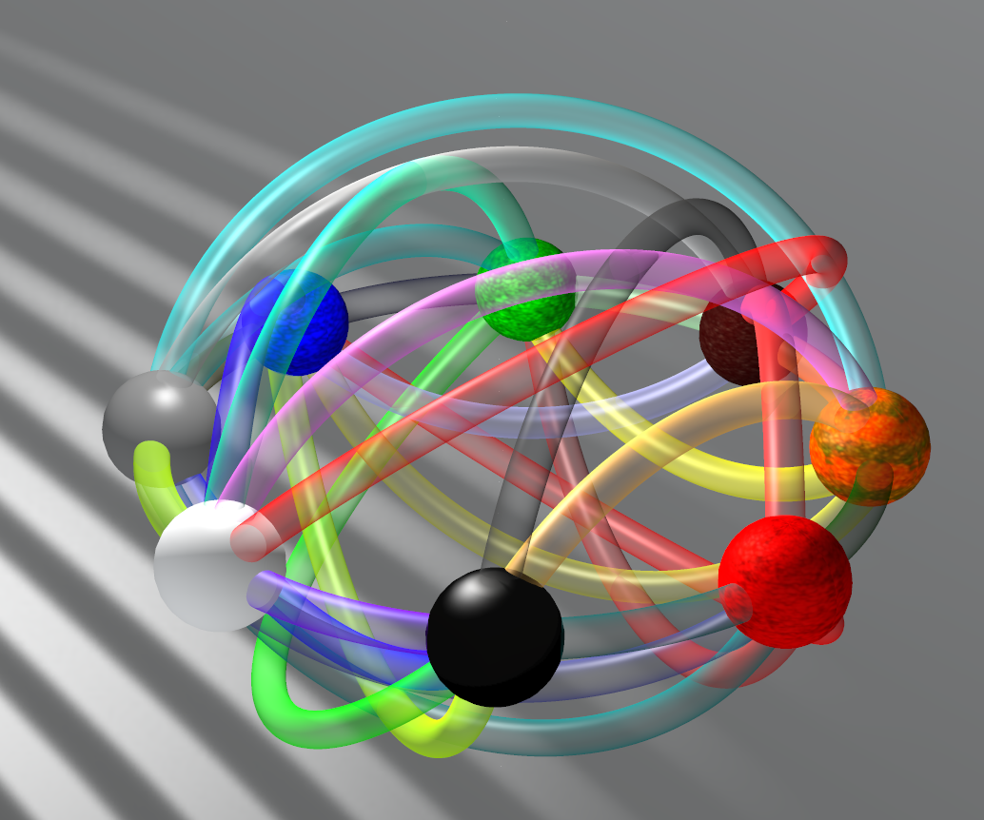
The image on the left shows all three sephiroth of consciousness, Yesod, Tiphareth, and Daath and the paths connecting them. This is called the Pillar of Consciousness. The image includes Dion Fortune's “secret path” connecting Daath and Yesod.

The image on the right shows the circle of sephiroth that surrounds the Pillar of Consciousness and the paths connecting them. It is called the Womb and includes all the other sephiroth on the Tree.

The Pillar of Consciousness can be interpreted as a lingam symbol, and the Womb can be interpreted as a yoni symbol. Notice that the Pillar of Consciousness and the Womb cannot separately produce all of the paths on the Tree, even though they contain all the sephiroth between them. It is only when they are joined that all the paths appear.
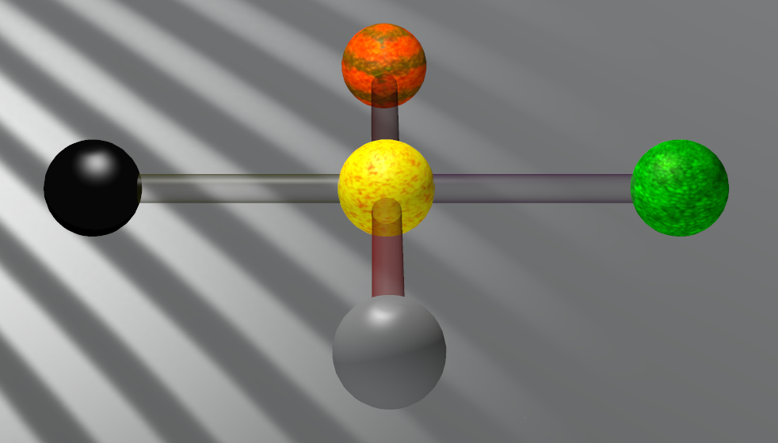
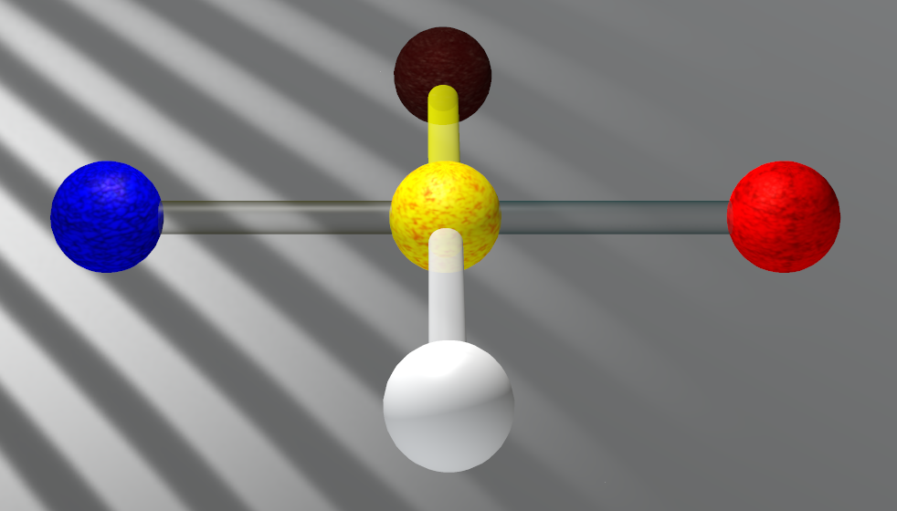

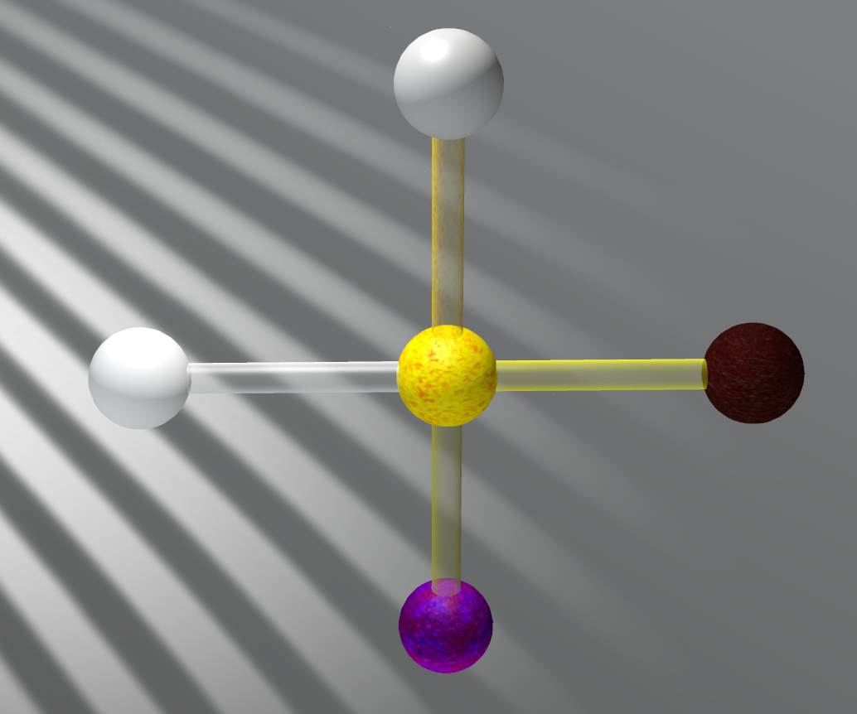
The Cross of Sex, left and Cross of Power, right. Clockwise from the gray sphere, the Cross of Sex has Chokmah (Active Male), Binah (Passive Female), Hod (Passive Male) and Netzach (Active Female). Tiphareth is in the center of the cross. Clockwise from the white sphere, the Cross of Power has Kether (Active Submission), Chesed (Passive Ruling), Malkuth (Passive Submission), and Geburah (Active Ruling).
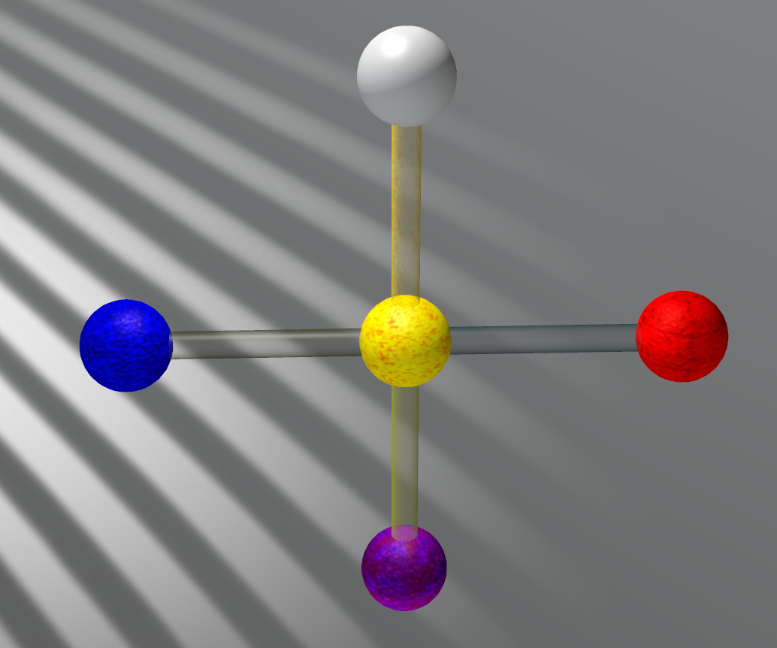
The Pillar of Consciousness can form four crosses with the sephiroth that encircle it. Shown left are the “Cross of Submission”, far left, and the “Cross of Ruling”, left. The Cross of Submission includes
Kether (Active Submission), and Malkuth (Passive Submission). The Cross of Ruling includes Geburah (Active Ruling) and Chesed (Passive Ruling).

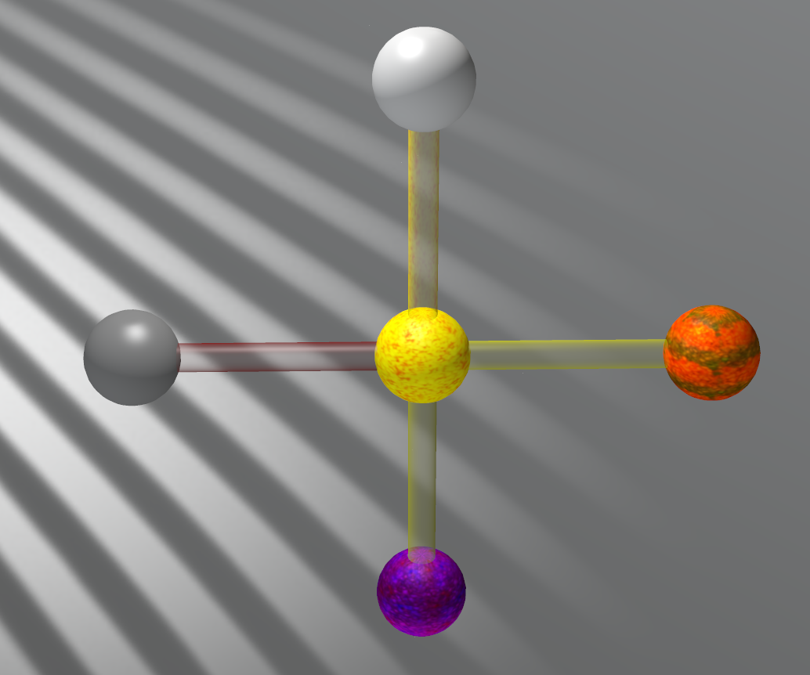
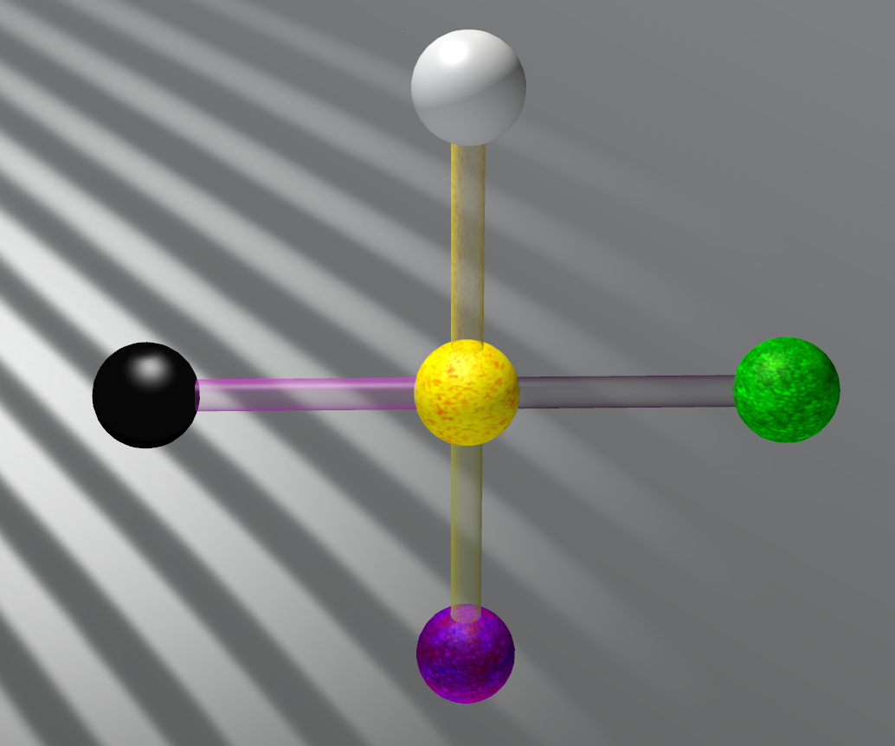
The other two crosses that can be formed from the Pillar of Consciousness are the “Cross of Man”, left, and the “Cross of Woman”, right. The Cross of Man includes Chokmah and Hod. The Cross of Woman includes Binah and Netzach.

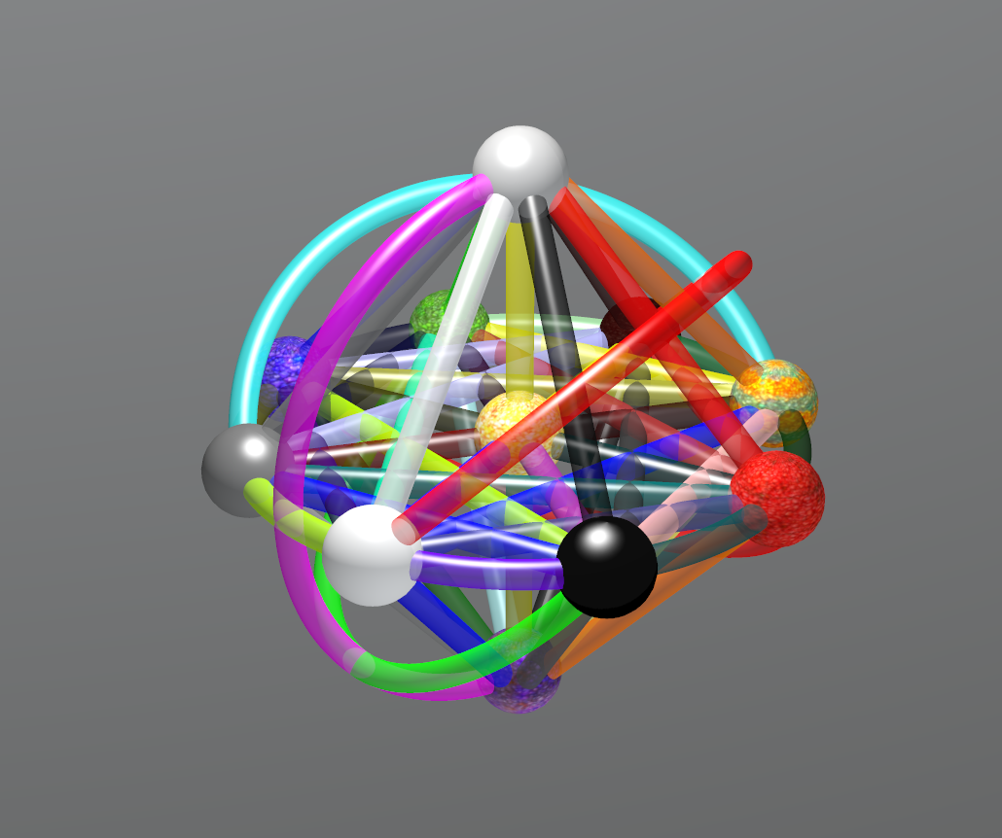
An alternate rendering of the Tree of Life in 3D, with most of the sephiroth of the Womb connected by a octogram and an octogon. A octogon is two squares and these squares contain the four sex sephiroth and the four power sephiroth.

The octogram gives 16 alternatives to the “lightening flash” of the traditional tree: Start at any of the eight sephiroth in the circle, trace the octogram around the circle, after the eighth sephiroth, go to Tiphareth. The lightening then goes to Yesod (Passive Feeling) and then to Daath (Active Reason). In this scheme, any of the eight sephiroth on the circle can fill the roll of “The Beginning”. The type of force manifested differs with each and with which way you trace the octogram. Further, each of the lightening flashes can be reversed by starting at Daath. This gives a total of 32 flashes.

Finally, we have paths connecting sephiroth on opposite sides of the Tree. These paths give important clues to the nature of the forces. Malkuth to Kether, Key of Submission: Love. Chokmah to Hod, Key of Man: Discovery. Binah to Netzach, Key of Woman: Blood. Geburah to Chesed, Key to Ruling: Strength (or Lust, or Death). Yesod to Daath, Key to Consciousness: Humility. The names of these keys are the names of the Tarot Trumps assigned to those paths. These will be presented in the next chapter.

i http://en.wikipedia.org/wiki/Christian_Kabbalah
ii http://en.wikipedia.org/wiki/Hermetic_Qabalah
iii http://en.wikipedia.org/wiki/Practical_Kabbalah
iv http://en.wikipedia.org/wiki/Hermetic_Qabalah#History
v http://en.wikipedia.org/wiki/Hermetic_Qabalah#Tarot_and_the_Tree_of_Life
vi http://www.thelemapedia.org/index.php/Zodiac_and_the_Tree_of_Life
vii http://en.wikipedia.org/wiki/Hermetic_Qabalah#The_Sephiroth_in_Hermetic_Qabalah
viii http://www.digital-brilliance.com/themes/tol.php
ix http://hermetic.com/crowley/libers/liber777.pdf
x http://en.wikipedia.org/wiki/777_and_other_Qabalistic_writings_of_Aleister_Crowley#Liber_777
xi http://en.wikipedia.org/wiki/Divinatory,_esoteric_and_occult_tarot
xii http://en.wikipedia.org/wiki/Hermetic_Qabalah#Tarot_and_the_Tree_of_Life
xiii Fortune, Dion. The Mystical Qabalah. Weiser Books. ISBN 978-1-57863-150-6. Chapter 28 Subjective Path Workings
xiv Crowley, Aleister. The Book Of Thoth. Weiser Books. ISBN 0-87728-268-4. The Atu of Tahuti
xv Fortune, Dion. The Mystical Qabalah. Weiser Books. ISBN 978-1-57863-150-6. Editorial Update
xvi http://en.wikipedia.org/wiki/Sephirot
xvii http://hermetic.com/achad/anatomy/anatomy3.htm

It is a valid criticism to say the three axioms given here cannot reconstruct the diagrammatic representation of the Tree of Life. There is nothing in these axioms which says Kether should be at the top of the Tree and Malkuth at the bottom, or that the Tree should form three “pillars”, etc. This criticism, while acknowledged, is dismissed as unimportant to the analysis presented here. If desired, new axioms can be presented that dictate the ordering of the sephiroth in a way that reproduces the diagrammatic representation. In fact, Aleister Crowley provided a set of rules in his book “777”. They are presented in his comments to column XII.
The colors differ from those given in Aleister Crowley's book “777”, which has many errors in it (e.g. some “traditional” zodiac colors are not the actual traditional colors) and does not follow the basic theory of the color models (e.g. not all primary colors assigned for a given model).

